# Kernel SVM

In the previous section we saw how the simple SVM algorithm can be used to find decision boundary for linearly separable data. However, in the case of non-linearly separable data, such as the one shown in Fig. 3, a straight line cannot be used as a decision boundary.

In case of non-linearly separable data, the simple SVM algorithm cannot be used. Rather, a modified version of SVM, called Kernel SVM, is used.

Basically, the kernel SVM projects the non-linearly separable data lower dimensions to linearly separable data in higher dimensions in such a way that data points belonging to different classes are allocated to different dimensions. Again, there is complex mathematics involved in this, but you do not have to worry about it in order to use SVM. Rather we can simply use Python's Scikit-Learn library that to implement and use the kernel SVM.

# 1. Polynomial Kernel

In the case of [polynomial kernel](https://en.wikipedia.org/wiki/Polynomial_kernel), you also have to pass a value for the degree parameter of the SVC class. This basically is the degree of the polynomial. Take a look at how we can use a polynomial kernel to implement kernel SVM:

# 2. Gaussian Kernel

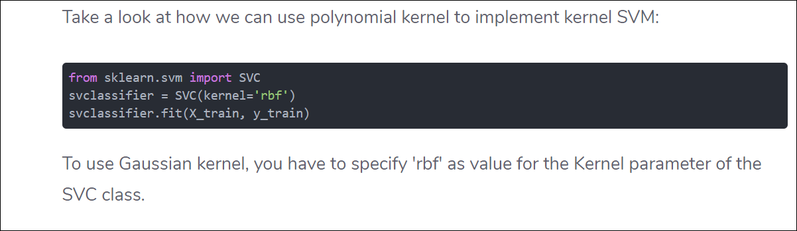

# 3. Sigmoid Kernel

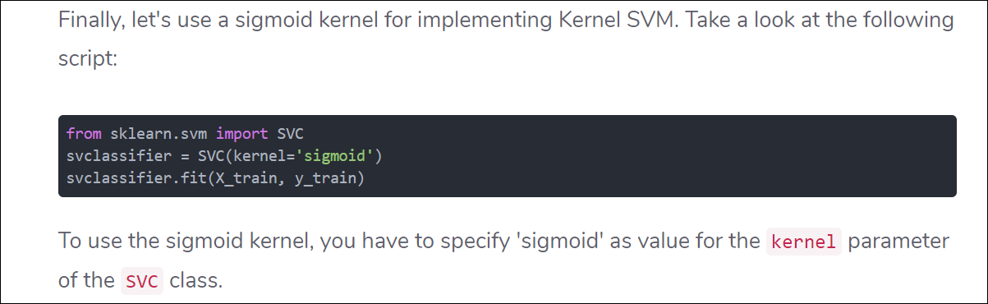

# Which Kernel to use

In general, the RBF kernel is a reasonable rst choice.Furthermore,the linear kernel is a special case of RBF,In particular,when the number of features is very large, one may just use the linear kernel.